
North Bengal International University

Lab Report: 04
Exp Name : Design and Implementation of ER Diagram

Subject : Database management system sessional
Subject Code : CSE 0612-3122

Submitted By:
Name : Md. Tanvir Rahman Pranto
Dept : CSE
Roll : 0712340012101005
Semester : 3nd Year, 5th semester.

Submitted To:
Name : Saifur Rahman
Designation : Lecturer
Dept : CSE
Date :

Data Table:
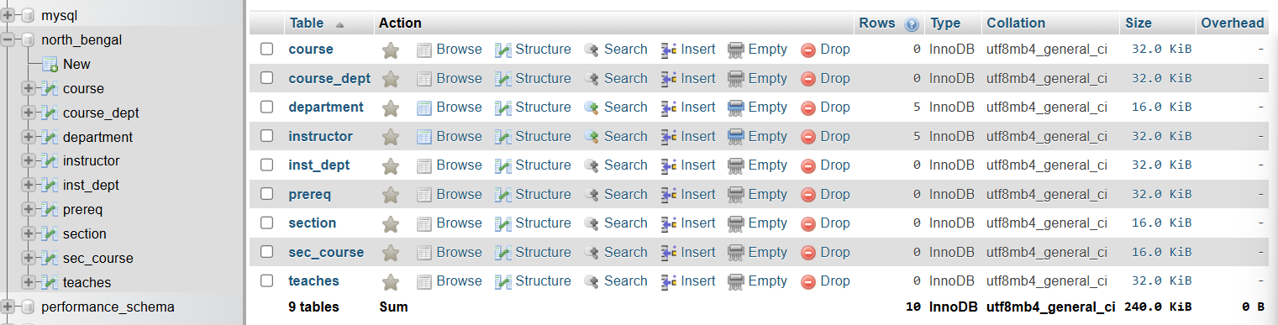

Design:
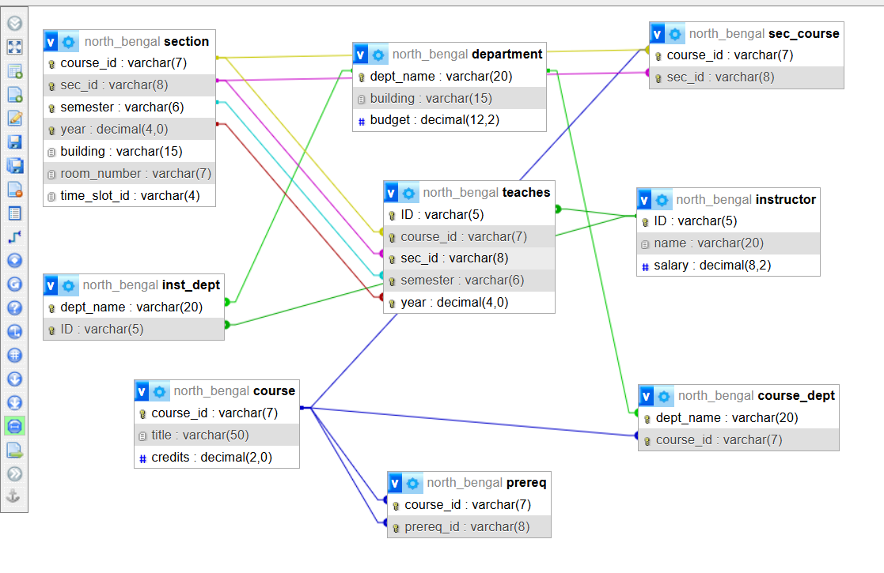

Conclusion: In this lab, we created several relational tables with composite primary keys and foreign key constraints to represent links between courses, sections, departments, and instructors. These table designs ensure data consistency and help model real academic relationships accurately. Overall, the lab highlights proper relational schema design and referential integrity in a database system.

Index

S/N | Topics | Page
1.  2.  3.  4.  5. | Experiment Name  Schema  Schema Design  Data Table  Design | 1  1  1  2  2

